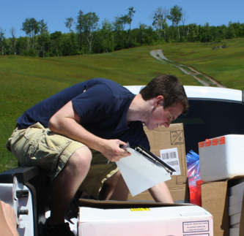
Matt Nunn (Hons) – completed his honours thesis investigating “Pheromones of the Red-Striped Fireworm”, and simultaneously completed a side project to examine leafhopper diversity in wild Nova Scotian blueberry fields.

